Human vs machine makings decision on driving activities (traffic tracking)

Weather tracking activities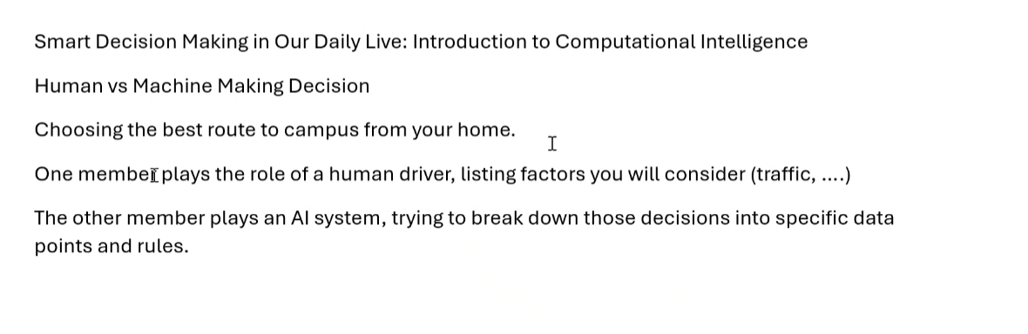  
  
Decision : Best route

Decisions data points and rules

Factors need to be consider 👍

**Human Driver's Decision-Making Process:**

* Considers **traffic conditions**, **roadblocks**, **weather**, and **shortcuts**.
* Uses past experience and intuition.
* May check live traffic updates manually (e.g., asking friends or checking Google Maps).

**AI System's Decision-Making Process:**

* Collects real-time data from traffic sensors, GPS, and weather forecasts.
* Uses **historical data** and **machine learning** to predict the best route.
* Considers **speed limits, congestion, and road closures** automatically.
* Optimizes the route based on efficiency, not just intuition.

**AI**

### **1. Problem Understanding**

The AI must determine the best route from home to campus by considering:

* **Traffic conditions** (real-time congestion, accidents)
* **Road conditions** (closures, maintenance)
* **Weather conditions** (rain, fog, floods)
* **Historical data** (past travel patterns)
* **Alternative routes** (fastest vs. shortest)

### **2. Data Collection**

To make accurate decisions, the AI would collect and process data from multiple sources:

* **Google Maps API / Waze API** (real-time traffic data)
* **GPS Sensors** (location tracking)
* **Weather API** (current weather updates)
* **Road Authority APIs** (construction, accidents, roadblocks)

### **3. Decision-Making Model**

I would implement a **Machine Learning (ML) model** using **Reinforcement Learning** or \**Graph-based Algorithms (Dijkstra’s or A* Algorithm)**:

* **Reinforcement Learning**: The AI learns from past decisions, optimizing for faster and safer routes.
* \**Graph-based Pathfinding (A* or Dijkstra’s)**: The system models the road network as a graph, where intersections are nodes and roads are edges, and then calculates the shortest or fastest path.

### **4. AI vs Human Simulation**

* **Human Approach**:
  + Manually checks traffic apps, listens to the news, or uses intuition.
  + May choose a familiar route instead of the most optimal one.
* **AI Approach**:
  + Analyzes millions of data points instantly.
  + Adjusts the route dynamically based on real-time data.
  + Predicts congestion and suggests alternate routes.

### **5. Implementation**

A **Python-based AI system** could be built using:

* **TensorFlow/PyTorch**: Train a model on historical traffic data.
* **Google Maps API**: Get live traffic updates.
* **NetworkX**: Graph-based pathfinding for route optimization.
* **Flask/FastAPI**: Deploy as a real-time routing service.

### **6. Output**

The AI system would **recommend the best route in real-time** and **adapt dynamically** to traffic changes, outperforming human decision-making in efficiency and accuracy.

Would you like me to generate sample Python code for this? 🚀

1️⃣ **Collect Real-Time Traffic Data** (Google Maps API)

2️⃣ **Optimize Route Selection** (Dijkstra's or A* Algorithm)

3️⃣ **Deploy a Simple Flask API** for real-time route recommendations